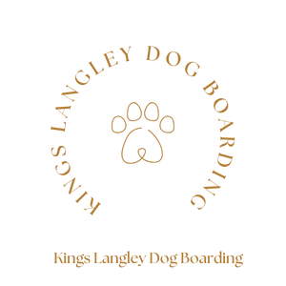

Grooming with Kings Langley Dog Boarding
Grooming Services Price List
All grooming services are arranged through me, so you can sit back and relax while I take care of everything! I’ll personally take your pup to our trusted groomer and bring them back looking (and smelling) fabulous — ready for you to collect, all spruced up and waggy-tailed. 🛁🐾✨
Full Groom
Small Dog | £60, Medium Dog | £70, Large Dog | £80, XL Large Dog | £90,
Incl: Bath & Blow Dry | Full Groom & Restle | Nail clipping & Ear cleaning | Dog Cologne
Bath & Blow Dry
X Small Dog | £20 - £25, Small Dog |£35, Medium Dog | £45, Large Dog | £55, XL Large Dog | £65,
Incl: Bath & Blow Dry & Brush | Ear Cleaning | Tear Stain Remover | Dog Cologne
Gentle Puppy Intro Grooming | 1-Hour
X Small Dog | £30 - £35, Small Dog |£40, Medium Dog | £50, Large Dog | £60, XL Large Dog | £70,
Incl: Bath & Blow Dry | Eye, Paw & Hygiene Trim | Nail clipping & Ear cleaning
Walk-In Nail Clipping: Easy Trims | £15 & Tricky Clients | £20

